**INSTITUTE OF ENGINEERING**

ADVANCED COLLEGE OF ENGINEERING AND MANAGEMENT

Kupondole, Lalitpur

**(AFFILIATED TO TRIBHUVAN UNIVERSITY)**



Lab No:2

Subject: Simulation And Modeling

**Submitted By: Submitted To:**

Department of Computer

and

Electronics Engineering

Name: Sameep Dhakal

Roll no: ACE074BCT063

Date: 2/28/2022

# LAB 2 : Random Number Generation

## Objective: Generate random numbers using c programming

## Theory:

The ability to generate random numbers can be useful in certain kinds of programs, particularly in games, statistical modelling programs, and cryptographic applications that need to encrypt and decrypt things. Take games for example -- without random events, monsters would always attack you the same way, you’d always find the same treasure, the dungeon layout would never change, etc… and that would not make for a very good game.

In real life, we often produce randomization by doing things like flipping a coin, rolling a dice, or shuffling a deck of cards. These events aren’t actually random, but involve so many physical variables (e.g. gravity, friction, air resistance, momentum, etc…) that they become almost impossible to predict or control, and (unless you’re a magician) produce results that are for all intents and purposes random.

computers are generally incapable of generating truly random numbers (at least through software). Instead, modern programs typically simulate randomness using an algorithm.

In this lab, we’ll cover a lot of the theory behind how random numbers are generated in programs, and introduce some terminology.

## Source code:

#include<stdio.h>

#include<conio.h>

#include<math.h>

int main()

{

int p=16,r0=45,b=3,a=5,n=100,rold,rnew,i,ct;

static int f[16] = {0};

float e,chi = 0.0;

//clrscr();

e = (float)n/p;

rold = r0;

printf("Random Numbers:\n");

for(i=1;i<=100;i++)

{

rnew = (rold*a+b)%p;

rold = rnew;

printf("%d\t",rold);

for(ct=0;ct<=15;ct++)

{

if(rold==ct)

f[ct]++;

}

}

printf("\nFrequencies:\n");

for(ct=0;ct<16;ct++)

printf("\tf[%d]=%d\t",ct,f[ct]);

for(i=0;i<p;i++)

chi+=pow((e-f[i]),2)/e;

printf("\n\nChi Square value = %f",chi);

if(chi<=24.996)

printf("\nnAccepted !!!");

else

printf("\n\nRejected !!!");

getch();

}

## Output:

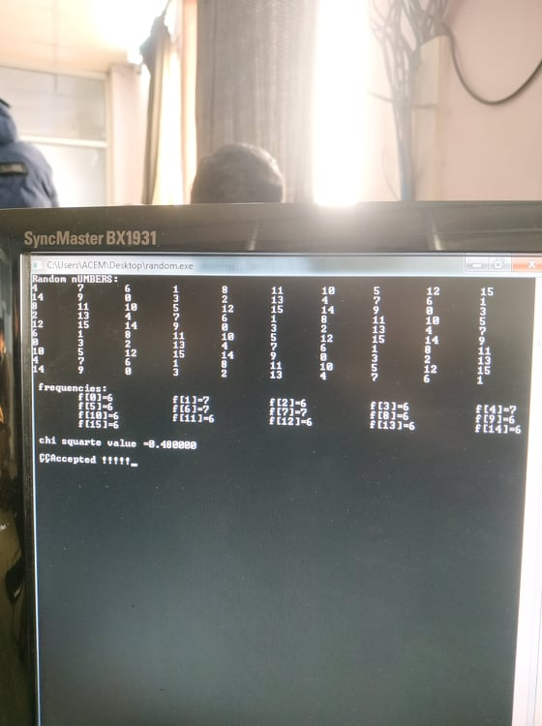

## Discussion And Conclusion:

In this lab we generated random number using c programming , we also analysed the frequency of occurance of the numbers. Moreover we calculated chi square value to find out whether the numbers generated is accepted or not.